CDS cmd

// db display

cds deploy --to sqlite:bookshp.bd

settings->sqlite->connections -- add value

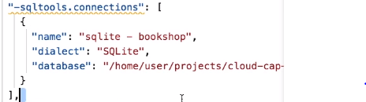

Compile data based with data:

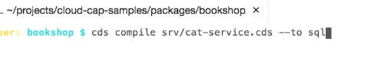

Set Hana environment in prod

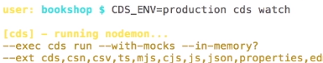

Hana database:

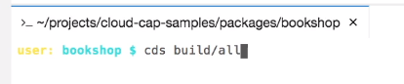

Create service in CF :

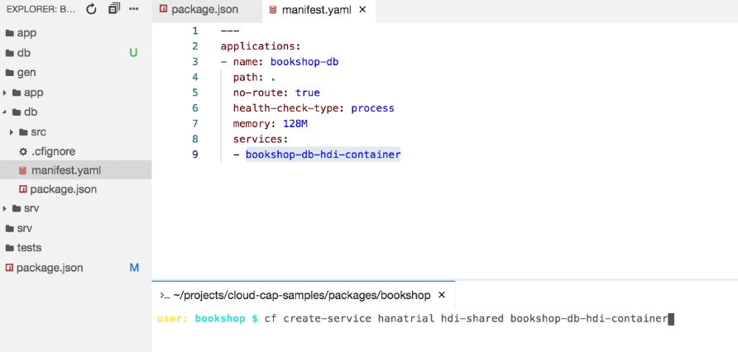

MTA deployment :

Cds add mta

Mbt build

Cf deploy :

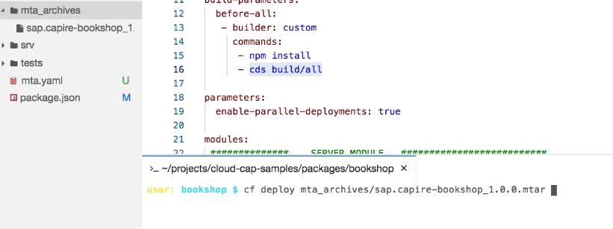

Database table and views :

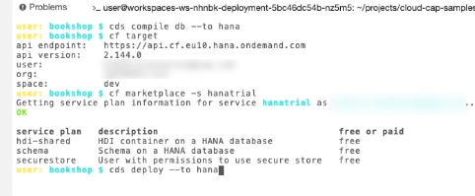

Run Prod version :

